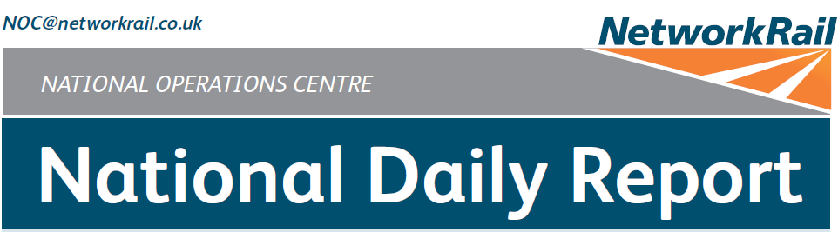



***DATE OF REPORT: NOC MANAGER 0700 – 1900:***

***NOC MANAGER 1900 – 0700:***

***DUTY CONTROLLER 0630 – 1830:***

***DUTY CONTROLLER 1830 – 0630:***

***SUPPORT CONTROLLER 0630 – 1830:***

***SUPPORT CONTROLLER 1830 – 0630:***

***LONDON CONTROLLER 0630 – 1830:***

***LONDON CONTROLLER 1830 – 0630:***

Saturday 11th January 2020 Jody Keogh

David Burnett Bob Scoot Mark Robinson

Graham Mcintosh Peter Ure Cornelius Edjah Martin Dineen

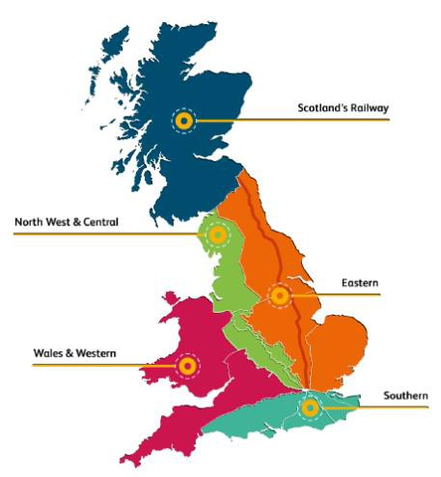

# TABLE OF CONTENTS

WRONG SIDE FAILURE REPORTS 3

SIGNALS PASSED AT RED (CATEGORY ‘A’) 3

DERAILMENTS 3

COLLISIONS 3

TRAIN OR VEHICLE RUNAWAY 3

OPERATIONAL INCIDENTS 4

STRANDED TRAINS 5

SIGNIFICANT POSSESSION PROBLEMS 5

FATALITIES 5

INJURIES/ASSAULTS 6

NEAR MISSES 6

RAILWAY CRIME 7

STATION OVERRUNS 7

BROKEN RAILS/TRACK DEFECTS 7

POWER FAILURES 7

POINTS FAILURES 7

SIGNALS/SIGNALLING SYSTEMS FAILURES 7

TRACK CIRCUIT & AXLE COUNTER FAILURES 8

BRIDGE STRIKES 8

ROAD VEHICLE INCURSIONS (NON-LEVEL CROSSINGS) 8

TRACTION FAILURES 8

WEATHER-RELATED PROBLEMS 9

FIRES 12

WILD REPORTS & HABD ACTIVATIONS 12

GROUP STANDARDS GE/RT8250 & GO/RT3350 13

TPWS 13

MISCELLANEOUS 13

REVIEW TABLE 15

REAL TIME PERFORMANCE FIGURES 16

None.

***01 WRONG SIDE FAILURE REPORTS***

***02 SIGNALS PASSED AT RED (CATEGORY ‘A’)***

## Eastern (East Coast or North and East) – CCIL 2076172 / Fault No. 783931

At 0740, 2H15, Northern, 0717 Skipton - Leeds, passed L4004 signal on the Up Shipley Main line between Bingley Tunnel and Saltaire at red. When questioned, the driver stated that they had braked late (group 2 cause). After consultation with Northern, the driver was judged fit to continue. The driver was later relieved of duty for interview.

|  |  |  |  |  |  |  |  |
| --- | --- | --- | --- | --- | --- | --- | --- |
| TRUST 682366 TEDX | | | | | | | |
| Cancelled | 0 | Part Cancelled | 0 | Trains Delayed | 2 | Minutes | 12 |

***03 DERAILMENTS***

None.

***04 COLLISIONS***

None.

***05 TRAIN OR VEHICLE RUNAWAY***

None.

## Eastern (East Coast) – CCIL 2076104

At 0505, the driver of 5P10, TransPennine Express, 0419 York – York, formed by set 802210, consisting of five coaches in all, reported that they were unable to lower the pantograph at York platform 4. It transpired that the driver should have lowered the pantograph before departing platform 3, this resulted in the train running off the OLE and the pantograph going over height, as platform 4 is not wired. A Mobile Operations Manager, OLE staff and Hitachi technical staff were mobilised to site, the Mobile Operations Manager reported that there was no physical damage visible to the OLE. Hitachi technical staff advised that the pantograph appeared to have broken and that the height limiter had failed to operate. At 0640 the OLE staff confirmed there was no damage to the OLE, but the pantograph had come into contact with the station canopy, damaging several glass panels. A block to traffic was placed at 0727. Following rectification work the train was able to depart at 1000 under diesel traction with the pantograph secured. The block to services remained in place due to the broken glass panels. It was discovered that there was no warning signage for drivers advising that platform 4 is not wired. This was raised with the OLE engineer, with a repair plan for the damaged glass being agreed with operators at a later date.

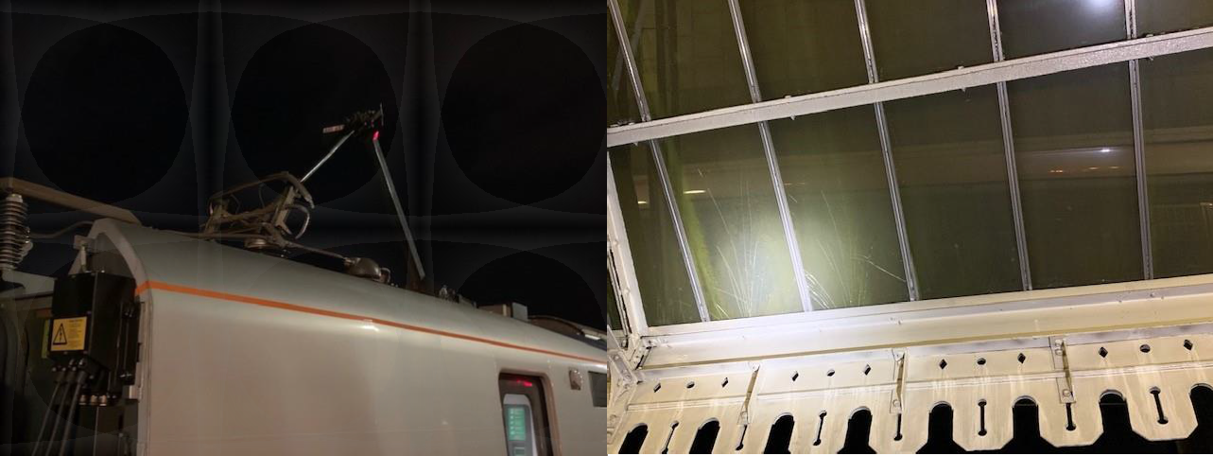

|  |  |  |  |  |  |  |  |
| --- | --- | --- | --- | --- | --- | --- | --- |
| TRUST 682125 TEAY | | | | | | | |
| Cancelled | 2 | Part Cancelled | 0 | Trains Delayed | 34 | Minutes | 171 |

## Eastern (East Coast) – CCIL 2076142

At 0710, the signaller at Tweedmouth reported that 1E03, London North Eastern Railway, 0624 Edinburgh Waverley – Peterborough had not received the broadcast for an ESR. The signaller replaced TW162 signal at Berwick-upon-Tweed station to red to allow the driver to be advised This resulted in TW178 signal on the Up Main line north of the station to also revert to red in front of the train. The driver was unable to stop and passed the signal at red. The driver was fit to continue when the circumstances were explained.

***06 OPERATIONAL INCIDENTS (CONT.)***

## North West & Central (North West) – CCIL 2076496

At 2355, the driver of 2B57, Northern, 2256 Buxton - Manchester Piccadilly, reported running over a detonator and bringing the train to a stand short of a Possession Limit Board (PLB) on the Down Slow line at Stockport Edgeley Junction No. 2. Initial investigations revealed that the signaller at Stockport Edgeley Junction No. 2 SB had signalled the train from the Down Hope Valley line onto the Down Slow line that was blocked by LNWN WON 42, Item 126, various lines blocked including Edgeley Junction No.1 SB and Edgeley Junction No. 2 SB, Down Slow possession, 2235 (Sat) to 0505 (Mon). Arrangements were made with the PICOP for the PLB and detonators to be removed, so that the service could be routed onto the Down Fast line, achieved 0010. A Mobile Operations Manager was sent to Stockport Edgeley Junction No. 2 SB to interview the signaller. The Local Operations Manager was advised and an investigation into the incident was commenced.

|  |  |  |  |  |  |  |  |
| --- | --- | --- | --- | --- | --- | --- | --- |
| TRUST 684139 OQR9 | | | | | | | |
| Cancelled | 0 | Part Cancelled | 0 | Trains Delayed | 3 | Minutes | 51 |

***07 TRAINS WITH STRANDED PASSENGERS***

|  |  |  |  |  |  |
| --- | --- | --- | --- | --- | --- |
| ***Region / Route*** | ***Train*** | ***Since*** | ***Between*** | ***OUTCOME*** | ***CCIL*** |
| W&W (Wales) | 1H81, Transport for Wales, 0610 Shrewsbury – Manchester Piccadilly | 0611 -  0756 | Shrewsbury - Gobowen | Assisting unit arranged. No issues with 5 passengers on board. | 2076118 |
| Scotland | 9M53, Avanti West Coast, 1000 Glasgow Central – London Euston | 1101 -  1209 | Beattock - Wamphray | Following P’Way authorising line to reopen the service was able to proceed. | 2076259 |
| Scotland | 1M95, TransPennine Express, 1012 Edinburgh Waverley – Manchester Airport | 1101 -  1209 | Beattock - Wamphray | Following P’Way authorising line to reopen the service was able to proceed. | 2076259 |
| Scotland | 1S42, Avanti West Coast, 0730 London Euston – Glasgow Central | 1105 -  1209 | Wamphray - Lockerbie | Following P’Way authorising line to reopen the service was able to proceed. | 2076259 |
| Scotland | 9M54, Avanti West Coast, 1052 Edinburgh Waverley – London Euston | 1124 -  1209 | Beattock - Wamphray | Following P’Way authorising line to reopen the service was able to proceed. | 2076259 |
| Sussex | 2F70, Govia Thameslink Railway, 2220 London Victoria – London Bridge | 2250  - 2320 | Sydenham Spur | Train on the move after person apprehended by the BT Police. | 2076482 |
| Sussex | 9J74, Govia Thameslink Railway, 2155 Horsham – Finsbury Park | 2251 –  2320 | Sydenham Up Junction | Train on the move after person apprehended by the BT Police. | 2076482 |
| Sussex | 9D70, Arriva Rail London, 2246 West Croydon – Dalston Junction | 2257 –  2320 | Penge West – Sydenham | Train on the move after person apprehended by the BT Police. | 2076482 |
| Sussex | 1P70, Govia Thameslink Railway, 2220 Caterham – London Bridge | 2300 –  2323 | Sydenham – Penge West | Train on the move after person apprehended by the BT Police. | 2076482 |
| Sussex | 1P71, Govia Thameslink Railway, 2247 London Bridge – Caterham | 2250 -  2323 | Forest Hill | Train on the move after person apprehended by the BT Police. | 2076482 |
| Sussex | 2T69, Govia Thameslink Railway, 2242 London Bridge – Coulsdon Town | 2256 -  2335 | Honor Oak Park – Forest Hill | Train on the move after person apprehended by the BT Police. | 2076482 |
| Wessex | 2J52, South Western Railway, 1853 Guildford – Farnham | 1915 –  2022 | Aldershot and Farnham | Stood whilst driver attempted to clear the line of debris | 2076416 |

***08 SIGNIFICANT POSSESSION PROBLEMS***

None.

***09 FATALITIES***

None.

***10 INJURIES/ASSAULTS***

## Wales & Western (Western) – No CCIL raised

At 0440 it was advised that a member of Ganymede staff had fallen and dislocated their knee whilst they were working with ballast at Dawlish Warren. The injured party was accompanied to hospital for treatment.

## Southern (Sussex) – CCIL 2075990

At 0450 a member of contractor’s staff, employed by Short Term, working for Works Delivery as a Crane Controller sustained an arm injury whilst working at Thornton Heath. The injured person was attaching equipment to an on track machine when the operator lowered the arm of the machine instead of raising it, striking the person on the arm. The person attended hospital for assessment.

## North West & Central (Central) – CCIL 2076408

At 1828, it was reported that a passenger on 2I83, West Midlands Trains, 1747 Rugeley Trent Valley – Birmingham International, had suffered a puncture wound to the finger after coming into contact with a needle that was wrapped in a newspaper at Rugeley Trent Valley. The injured party alighted at Walsall to seek medical assessment.

***11 NEAR MISSES***

## Eastern (EM) – CCIL 2076265

At 1125, the driver of 2L60, West Midlands Trains, 1036 Lincoln Central - Leicester, reported a near miss at Cheshunt Grove foot crossing at Lowdham station with a cyclist, who crossed in front of the train. The driver applied the emergency brake and the cyclist cleared the crossing. The driver was fit to continue. A Mobile Operations Manager attended and confirmed all signage correct and in place.

## North West and Central (WCMLS) – CCIL 2076261

At 1127, the driver of 2S12, West Midlands Trains, 1104 Bedford – Bletchley, reported a near miss at Lidlington station with two people who ran across in front of the approaching train. The driver reported that they had applied the emergency brake. The people involved were seen to remain on the station platform. The driver was shaken by the incident and was met on arrival at Bletchley. The BT Police (ref. 189) were advised. A Mobile Operations Manager attended and reported no one seen and confirmed all signage correct and in place.

|  |  |  |  |  |  |  |  |
| --- | --- | --- | --- | --- | --- | --- | --- |
| TRUST 682743 XQRA | | | | | | | |
| Cancelled | 0 | Part Cancelled | 0 | Trains Delayed | 2 | Minutes | 11 |

## Wales and Western (Western) – CCIL 2076299.

At 1243, the driver of 2T18, Great Western Railway, 1224 Exmouth – Exeter St. Davids, reported a near miss at Toffles FP crossing, between Topsham and Exton, with a person who crossed as the train approached, with the driver making an emergency brake application. The driver was fit to continue. The BT Police (ref. 226) were advised. A Mobile Operations Manager attended and confirmed the crossing in order at 1415.

|  |  |  |  |  |  |  |  |
| --- | --- | --- | --- | --- | --- | --- | --- |
| TRUST 682926 XQDZ | | | | | | | |
| Cancelled | 0 | Part Cancelled | 0 | Trains Delayed | 5 | Minutes | 32 |

***11 NEAR MISSES (CONT.)***

## Eastern (Anglia) – CCIL 2076295

At 1252, the driver of 2D27, Arriva Rail London, 1231 Cheshunt – London Liverpool Street, reported a near miss on the Up Southbury line at Silver Street with a person standing in the cess. The driver was fit to continue. Subsequent services were cautioned with the Mobile Operations Manager sent to site. The caution was removed at 1308 after the area was reported to be clear. The BT Police (ref. 230) were advised. A Mobile Operations Manager attended confirming no person present.

|  |  |  |  |  |  |  |  |
| --- | --- | --- | --- | --- | --- | --- | --- |
| TRUST 682892 XQHM | | | | | | | |
| Cancelled | 0 | Part Cancelled | 0 | Trains Delayed | 4 | Minutes | 17 |

## Eastern (Anglia) – CCIL 2076301

At 1308, the driver of 2D32, c2c, 1253 London Fenchurch Street - Shoeburyness, reported a near miss at West Ham with a person who jumped onto the track to retrieve an item, returning to the platform as the train approached. The person was then seen to leave the station. The driver was fit to continue. The BT Police (ref. 236) were advised. A Mobile Operations Manager attended and confirmed the area clear.

|  |  |  |  |  |  |  |  |
| --- | --- | --- | --- | --- | --- | --- | --- |
| TRUST 682914 XQHM | | | | | | | |
| Cancelled | 0 | Part Cancelled | 0 | Trains Delayed | 1 | Minutes | 3 |

***12 RAILWAY CRIME***

## Southern (Sussex) – CCIL 2076482

At 2302, a member of Network Rail staff reported that there was a person standing on a bridge parapet Country side of Sydenham station. The driver of 9J74, Govia Thameslink Railway, 2155 Horsham – Finsbury Park that had been cautioned, stopped short of the bridge advising it was unsafe to pass. In response, all lines were blocked at 2304 with multiple trains stranded between stations, as detailed in section **07** of this report. The BT Police (ref. 594) reported as on site. The Selhurst Mobile Operations Manager, appointed RIO, was on site at 2306 with Land Sheriffs requested to site. Train running resumed at 2320, after it was advised that the person had been apprehended and taken into the care of attending ambulance staff. Some services were terminated at New Cross Gate to aid service recovery.

|  |  |  |  |  |  |  |  |
| --- | --- | --- | --- | --- | --- | --- | --- |
| TRUST 684041 XQMD | | | | | | | |
| Cancelled | 10 | Part Cancelled | 14 | Trains Delayed | 50 | Minutes | 829 |

***13 STATION OVERRUNS***

None.

***14 BROKEN RAILS/TRACK DEFECTS***

None.

***15 POWER FAILURES***

None.

***16 POINTS FAILURES***

None.

***17 SIGNALS/SIGNALLING SYSTEMS FAILURES***

None.

## Southern (Sussex) – CCIL 2076356 / Fault No. 158336

At 1550, track circuit ‘QS’ on the Down Fast line in the Salfords area failed, holding T223 signal at danger. S&T staff and the Mobile Operations Manager were sent to site. Services were cautioned past the signal or diverted to the Down Slow line. The track circuit cleared briefly at 1608 after the passage of a train, before failing again. The signal was keyed to red at 1637. Adjustments were made to cable leads which had become loose, which in turn restored the track circuit. However, due to a competency gap with the attending staff normal signalling could not be authorised. S&T confirmed that staff holding the requisite competencies to sign the failed asset into use would take duty at 1900. S&T staff completed testing by 2135 and the fault was placed in order.

|  |  |  |  |  |  |  |  |
| --- | --- | --- | --- | --- | --- | --- | --- |
| TRUST 683274 IQBG | | | | | | | |
| Cancelled | 0 | Part Cancelled | 5 | Trains Delayed | 138 | Minutes | 959 |

***19 BRIDGE STRIKES***

None.

***20 ROAD VEHICLE INCURSIONS (NON-LEVEL CROSSINGS)***

None.

***21 TRACTION FAILURES***

## North West & Central – North West – CCIL 2076404

At 1810, the driver of 1Y64, Northern, 1653 Blackpool North – Manchester Airport formed by unit 331105, reported that they had come to a stand on the Up Bolton line at Ordsall Lane Junction due to a Vacuum Circuit Breaker trip. The driver was able to overcome the fault and was on the move at 1831. However, at 1838 the driver advised that they were unable to depart platform 4 at Manchester Oxford Road as the fault had reoccurred. As such, there was no route towards Manchester Piccadilly from platform 3, with all services signalled via platforms 1 and 2. The driver took guidance from their maintenance department, after which the service was terminated, departing as ECS to Preston at 1920 from the Deansgate end. Significant reactionary delay was ensued.

|  |  |  |  |  |  |  |  |
| --- | --- | --- | --- | --- | --- | --- | --- |
| TRUST 683473 NED2 | | | | | | | |
| Cancelled | 1 | Part Cancelled | 9 | Trains Delayed | 78 | Minutes | 828 |

## Scotland – CCIL 2076088 / Fault No. 347668

At 0351, the Cumbernauld workstation reported that track circuit ‘7443’ on the Up Perth line at Carmuirs West Junction had failed after the passage of a train. S&T staff were sent to site, confirming at 0416 that there was flooding through the section. A Track Section Manager was on site from 0503, who advised that flood water was clearing into the drains. Linespeed was authorised at 0526. Services continued to be cautioned for the track circuit failure, with some services diverted via the E&G lines to ease congestion. However, by 1253 water levels had risen significantly, with the driver of 5Z25, Serco Caledonian Sleeper, 1003 Aberdeen – Polmadie Depot, reporting that the water was moving and that the drains were overwhelmed. 5Z25 was authorised to continue at 5mph, after which the Up and Down Perth lines were closed. By 1352 water levels had receded to allow both lines to be reopened at line speed, however, the track circuit remained failed and services continued to be cautioned. P’Way staff were on site from 2114, working under Line Blockage arrangements between trains attempting to divert the water from site. Further remedial work was arranged for after service.

|  |  |  |  |  |  |  |  |
| --- | --- | --- | --- | --- | --- | --- | --- |
| TRUST 682059 XQLF | | | | | | | |
| Cancelled | 23 | Part Cancelled | 8 | Trains Delayed | 180 | Minutes | 1562 |

## Scotland – CCIL 2076090 & 2076097 / Fault No. 347670 & 347674

At 0459, the Balavil Burn flood alarm at Kingussie advised water levels had reached the yellow warning marker, the on call structures engineer was notified as were P’Way staff. At 0545 the alarm advised water level had reached the red warning marker, a block to services was imposed until staff could expect the site, multiple services were trapped. P’Way staff were diverted to site and north bound services were held at Perth. Trapped services were terminated at Aviemore and Kingussie with taxi’s being supplied for passengers, 1S25, Serco Caledonian Sleeper Ltd, 2116 (Fri) London Euston – Inverness was held at Dunkeld. In addition, the line was closed at Gynack Burn from 0624 after water levels had risen following sustained rainfall. The block remained in effect and the structure was examined on a 30 minute basis. At 0701 the P’Way staff arrived on site and advised the water level were still exceeding the red line at Balavil Burn. A bus service was established between Perth at Inverness at 0744 and at 0805 the decision was made to return 1S25 to Perth. Both burns were monitored frequently throughout the day, with structures staff advising that both sites would remain blocked due to the amount of debris on the line that was unsafe to be removed, although water levels had receded to below the yellow line at both burns. The line remained closed until close of service. AMCO Engineers will attend site at 0830 Sunday to carry out an assessment.

Balavil Burn Gynack Burn

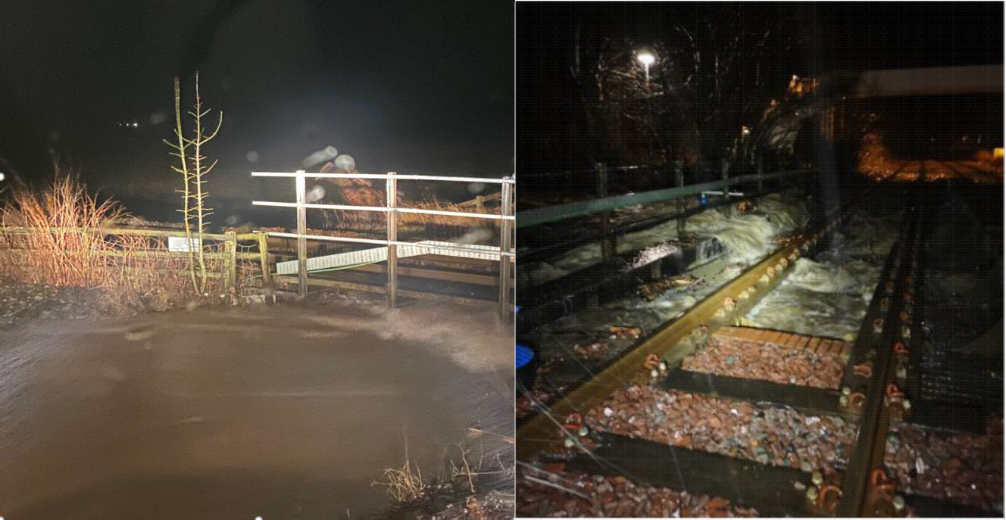

|  |  |  |  |  |  |  |  |
| --- | --- | --- | --- | --- | --- | --- | --- |
| TRUST 682086 XQLV | | | | | | | |
| Cancelled | 6 | Part Cancelled | 22 | Trains Delayed | 23 | Minutes | 181 |

## Eastern (East Coast) – CCIL 2076116 / Fault No. 347696

At 0600, a blanket 80 mph ESR was imposed for all electric traction between Belford Crossovers and the Scottish Border due to high recorded wind speeds. By 1010 the blanket speed was extended to include Newcastle. At 1210, following multiple reports of section MT2 OLE section tripping, the ESR was increased to 50mph for all trains between Newcastle and Belford. Services were cautioned over Beal CCTV level crossing as the signaller was unable to maintain the barriers in the lowered position. Line speed was authorised from 1453 after wind speeds had subsided.

|  |  |  |  |  |  |  |  |
| --- | --- | --- | --- | --- | --- | --- | --- |
| TRUST 682282 XQGL | | | | | | | |
| Cancelled | 0 | Part Cancelled | 0 | Trains Delayed | 210 | Minutes | 1841 |

## Scotland – CCIL 2076259 / Fault No. 347696

At 1101, the driver of 1S38, TransPennine Express, 0807 Manchester Airport – Edinburgh Waverley reported flooding at Wamphray GF between Lockerbie and Beattock, that was flowing at sleeper level. In response, the Down and Up West Coast Main lines were blocked to traffic. Three services were trapped in section (See section **07** of this report), with P’Way staff advised and mobilised to site. By 1205 P’Way staff reported that the water that was cascading from adjacent fields was below the rail head. The block to services was lifted and normal signalling resumed at 1209.

|  |  |  |  |  |  |  |  |
| --- | --- | --- | --- | --- | --- | --- | --- |
| TRUST 682761 XQLD | | | | | | | |
| Cancelled | 1 | Part Cancelled | 19 | Trains Delayed | 105 | Minutes | 2032 |

## Scotland – CCIL 2073298 & 2076304 / Fault No. 347703 & 347704

At 1254, the Shift Signalling Manager at Edinburgh IECC reported that track circuit ‘698’ & ‘724’ had failed on the Up E&G line at Winchburgh Junction. A following service was utilised to examine the line, reporting standing water at 1316. Services were authorised past affected signals at red, with some services started/terminated at Linlithgow. P’Way staff reported that pumps were not in operation upon their arrival. Pumps were switched on and operational from 1418. At 1605 P’Way undertook a cab ride to examine the line, reporting at 1642 that water levels were below the rail head. Track circuit ‘698’ cleared at 1744, and track circuit ‘724’ cleared at 1813, thus allowing trains to be signalled normally.

|  |  |  |  |  |  |  |  |
| --- | --- | --- | --- | --- | --- | --- | --- |
| TRUST 682897 XQLF | | | | | | | |
| Cancelled | 61 | Part Cancelled | 8 | Trains Delayed | 116 | Minutes | 1470 |

## Southern (Wessex) – CCIL 2076416 / Fault No. 460792

At 1839 the driver of 1A62, South Western Railway, 1815 Alton – Woking reported that the train had struck a branch on the Up line approaching Aldershot. Further trains were cautioned with the following driver stating at 1845 that the branch did not affect the passage of trains, with normal signalling resuming. It was subsequently reported by drivers the branch was brushing passing trains. The Woking Mobile Operations Manager was called to attend. At 1916 it was reported by train crew on 2J52, South Western Railway, 1853 Guildford – Farnham, that multiple branches were present over the running lines. An emergency switch off was taken with Eastleigh ECO to allow the offending branches to be removed. At 1945 the driver of 2J52 confirmed branches had been removed from the Down line, however, the Up line was still blocked by a tree branch. The Mobile Operations Manager was on site by 1950. The Up line was made safe for the passage of trains and the traction current recharged from 2023. At 2052 the driver of 1A66, South Western Railway, 1915 Alton – Woking advised the Up line was safe to pass at 5mph. Off Track staff attended and undertook further cutting back of the tree, with the entire specimen removed clear by 2140, and normal signalling being authorised at 2142.

|  |  |  |  |  |  |  |  |
| --- | --- | --- | --- | --- | --- | --- | --- |
| TRUST 683726 XQCW | | | | | | | |
| Cancelled | 21 | Part Cancelled | 3 | Trains Delayed | 40 | Minutes | 948 |

## Scotland’s Railway (Scotland) – CCIL 2076401 / Fault No. 347718

At 1814 the Shift Signaller Manager at Edinburgh IECC advised that track circuit No. 727 on the Down E&G line between Winchburgh and Linlithgow had failed, holding EW609 signal to red. S&T were called to attend and drivers authorised to pass EW609 at red. At 1844 the driver of 1R07, ScotRail, 1816 Edinburgh Waverley – Glasgow Queen Street, reported the presence of water at the site but was unsure of the depth. A resulting 5mph ESR was imposed. P’Way site were on site by 2010, advising that water levels were approximately ½ way up the rail and spread over a distance of 100 yards along the four foot. The ESR remained in place, being eased at 2205 after staff on site had been satisfied that water levels had receded. Linespeed was restored at 2252 after water levels continued to dissipate. P’Way staff attended overnight within a planned possession (Sc WON 42 Item 193 refers) to undertake checks and remedial maintenance to pumps located at the site.

|  |  |  |  |  |  |  |  |
| --- | --- | --- | --- | --- | --- | --- | --- |
| TRUST 683472 IQLE | | | | | | | |
| Cancelled | 2 | Part Cancelled | 4 | Trains Delayed | 75 | Minutes | 876 |

***23 FIRES***

None.

***24 WILD REPORTS & HABD ACTIVATIONS***

## Disconnected Hot Axle Box Detectors:

|  |  |  |  |  |  |  |  |  |  |
| --- | --- | --- | --- | --- | --- | --- | --- | --- | --- |
| *Region / Route* | *Location* | *Line* | *Date Disconnected* | *Reason* | *TOC’s/ FOC’s*  *advised* | *Planned Restoration Date* | *Date Restored* | *Function* | *Fault Number* |
| Eastern (EM) | Chiltern Green | Down Slow | 11/07/19 | Defective UPS, waiting spares | Y | Awaiting update |  |  | 148559 |
| Eastern (EM) | Napsbury | Up Fast & Up Slow | 11/07/19 | Defective UPS, waiting spares | Y | Awaiting update |  |  | 148559 |
| Eastern (LNE) | Barkston | Up Main | 01/04/19 | Removed for P’Way work | Y | Awaiting update |  |  | 719053 |
| Eastern (LNE) | Langley | Down Slow | 05/04/17 | Vermin | Y | Awaiting update |  |  | 665647 |
| Eastern (LNE) | Langley | Down Fast | 15/09/19 | Trackside cable damage | Y | Awaiting update |  |  | 769845 |
| Eastern (LNE) | Biggleswade | Up Fast | 22/12/19 | Loss of comms | Y | Awaiting update |  |  | 782151 |
| NW & Central (NW) | Low Mill | Down Main | 26/11/14 | Awaiting replacement | Y | Awaiting update |  | IP | 671852 |
| NW & Central (NW) | Sutton Weaver | Down Main |  |  | Y | Awaiting update |  |  |  |
| NW & Central (WCMLS) | Castlethorpe | Up Fast | 27/11/18 | Error code 6.0 | Y | Out of use – beyond repair. |  | IM | 832410 |
| NW & Central (WCMLS) | Harecastle | Up Main | 01/04/19 | Rail incorrectly drilled | Y | Awaiting Update |  |  |  |
| **Wales & Western (Western)** | **Cogload** | **Down Main** | **09/01/20** |  | **Y** | **Awaiting Update** |  |  | **457390** |

## Disconnected Wheel Impact Load Detectors:

|  |  |  |  |  |  |  |  |  |  |
| --- | --- | --- | --- | --- | --- | --- | --- | --- | --- |
| *Region / Route* | *Location* | *Line* | *Date Disconnected* | *Reason* | *TOC’s/ FOC’s*  *advised* | *Planned Restorati on Date* | *Date Restored* | *Function* | *Fault Number* |
| Eastern (LNE) | Sessay | Up Slow | 18/06/2019 | Calibration |  |  |  | IM |  |
| North West & Central (NW) | Heaton Chapel | Up Slow | 30/07/2019 | Calibration |  |  |  | IM |  |
| Southern (Kent) | Sevington | Down Main | 25/04/2018 | PC Failure |  |  |  | IM |  |
| Southern (Kent) | Sevington | Up Main | 09/08/2018 | PC Failure |  |  |  | IM |  |
| Southern (Kent) | Swanley | Up Slow | 02/04/2019 | Calibration |  |  |  | IM |  |
| Scotland | Howwood | Up | 20/01/2019 | HOBC |  |  |  | IM |  |
| Wales & Western (Western) | Urchfont | Up | 11/04/2019 | PC Failure |  |  |  | IM |  |
| Wales & Western (Western) | Urchfont | Down | 11/04/2019 | PC Failure |  |  |  | IM |  |

***25 GROUP STANDARDS GE/RT8250 & GO/RT3350***

None.

***26 TPWS***

|  |  |  |  |  |  |  |  |  |
| --- | --- | --- | --- | --- | --- | --- | --- | --- |
| ***Region*** | ***Route*** | ***Train*** | ***Signal/PSR/ Buffer Stop*** | ***Line/Platform*** | ***Location*** | ***Speed (reported)*** | ***Speed (set)*** | ***CCIL*** |
| Southern | Sussex | 1F13, Govia Thameslink Railway, 0720 Ore – Haywards Heath | 40 mph PSR | Up Lewes | Lewes | 50 | 40 | 2076191 |
| Eastern | East Midlands | 4E26, DB Cargo, 0856  Dollands Moor – Scunthorpe | 50mph PSR | Down Slow | Irchester | 76 | 76 | 2076279 |

***27 MISCELLANEOUS***

## Wales and Western (Western) – CCIL 2076110

At 0526, Thames Valley SC Bristol TM Workstation reported that 4V37, Freightliner, 2315 (Fri) Felixstowe North FLT – Bristol FLT, was at a stand on the Down Main line at Parson Street waiting acceptance into the Yard, with no shunter on site. Services were diverted via Westbury. The driver did not have route knowledge for any other access. Efforts to locate a replacement shunter were unsuccessful. A Mobile Operations Manager was sent to site to assist in case Single Line Working was required. Freightliner authorised the driver to take control of the Liberty Sidings in the absence of the shunter with the Mobile Operations Manager cutting off the padlock at the sidings entrance to gain access. The train was clear of the running lines by 0839.

|  |  |  |  |  |  |  |  |
| --- | --- | --- | --- | --- | --- | --- | --- |
| TRUST 682116 ADBF | | | | | | | |
| Cancelled | 4 | Part Cancelled | 12 | Trains Delayed | 40 | Minutes | 713 |

## Eastern (Anglia) – CCIL 2076192

At 0825 Greater Anglia staff reported that 1K65, Greater Anglia, 0827 Norwich – Stansted Airport, formed by unit 755424, was leaking fuel in platform 6 at Norwich. The unit was taken out of service with another unit utilised to form the service, which departed 22 mins late. A Mobile Operations Manager and fitter were sent to site. The fitter was unable to stem the leak. Spill kits were utilised, and specialist cleaning staff were summoned. There were no water courses or Sites of Scientific Interest in the area. All details were passed to the Environment Agency. At 0959 the fitter reported that the cause was a defective fuel filter. The leak had slowed but could not be fully stopped. By 1111 the leak had been stopped, allowing the unit to be assisted back to Crown Point Depot. It was estimated that several hundred litres of fuel had been lost.

|  |  |  |  |  |  |  |  |
| --- | --- | --- | --- | --- | --- | --- | --- |
| TRUST 682462 MEB4 | | | | | | | |
| Cancelled | 0 | Part Cancelled | 2 | Trains Delayed | 5 | Minutes | 43 |

## Eastern (Anglia) – CCIL 2076256

At 1106 the East London Line SCC was evacuated due to a fire alarm activation within the Operations Building Control (OBC). As a result, services between Highbury & Islington – New Cross / New Cross Gate

/ Old Kent Road Junction over the East London Lines were affected. All trains bar three were confirmed to be brought to a stand within platforms. The cause of the alarm was a result of a defective air filter system within the fire alarm mechanism for the OBC. The East London Line Workstation reopened from 1126, with all affected Arriva Rail London Services returned as ECS to destination or New Cross Gate Depot, before being restarted in the correct path for their respective workings.

|  |  |  |  |  |  |  |  |
| --- | --- | --- | --- | --- | --- | --- | --- |
| TRUST 682732 OEKA | | | | | | | |
| Cancelled | 91 | Part Cancelled | 38 | Trains Delayed | 15 | Minutes | 140 |

***28 REVIEW TABLE***

|  |  |  |
| --- | --- | --- |
| ***INCIDENT*** | ***TODAY’S TOTAL*** | ***DAYS SINCE LAST INCIDENT*** |
| **PASSENGER ACCIDENTAL FATALITIES** | **0** | **403** |
| **RAILWAY WORKFORCE FATALITIES** | **0** | **29** |
| **SIGNALS PASSED AT RED (CATEGORY ‘A’)** | **1** | **0** |
| **SIGNALS PASSED AT DANGER (ERROR/TECHNICAL SIGNAL REVERSION)** | **1** | **0** |
| **DERAILMENTS** | **0** | **24** |
| **TRAIN COLLISIONS** | **0** | **3** |
| **TRAINS STRIKING ROAD VEHICLES** | **0** | **19** |
| **ENVIRONMENTAL INCIDENTS** | **1** | **0** |

***29 REAL TIME PERFORMANCE FIGURES***

